SIMATS ENGINEERING
ASSESSMENT TOOL II — Visualization Analysis Report
Course: Data Handling and Visualization | Code: DSA06 | CO: CO5
Duration: 180 min | Total Marks: 100 | Reg No :  Name:

COURSE OUTCOME COVERED
CO5: Analyze and evaluate visualization choices to communicate patterns, comparisons, relationships, and potential misleading effects through appropriate visualization methods. (BL4)
Activity Tool : Visualization Analysis Report
Weightage: 20%
Code of Conduct:
I ______________________ (Name / Reg No) certify that this submission is my original work and that I have adhered to the guidelines specified for this assessment. I understand that any violation of academic integrity rules will result in disciplinary action.
Signature of the student: ______________________
Assessment Criteria
Criteria | Visualization  Selection and  Understanding 25% | Visualization  Analysis and  Interpretation 25% | Application of Visualization Principles  20% | Organization and Presentation 20% | Accuracy  10% | Clarity  5% | Total
Q1
Q2
Q3
Q4
Q5

AT2 – Visualization Analysis Report | Data Handling and Visualization | DSA06
Visualization Analysis Report – Assessment Tool
R Programming Practical Questions with Datasets
Instructions: Answer all five questions. Use R programming to construct the required visualizations, analyze the patterns, compare visualization choices where requested, and identify potential visualization pitfalls. Use the given data exactly unless a transformation is explicitly requested.
Q1. Comparing Distributions – Histogram, Density and ECDF
A quality-control team records the following processing times (in minutes) for 20 randomly selected tasks. Using R, create a histogram and a density plot for the data. Also construct an empirical cumulative distribution function (ECDF). Compare the three visualizations and explain which aspects of the distribution—center, spread, skewness, and cumulative behavior—are communicated most clearly by each.
Data: Time = 18, 21, 22, 24, 25, 25, 27, 28, 29, 30, 31, 32, 33, 35, 36, 38, 41, 43, 46, 50 Expected R tasks: histogram, density estimation, ECDF, appropriate labels/scales, comparison and interpretation. Q2. Q-Q Plot and Normality Analysis
A researcher measures the following response times (in seconds). Use R to create a normal Q-Q plot and a histogram/density visualization. Assess whether the observations are reasonably consistent with a normal distribution. Identify any departures from the reference line and explain what they indicate about the distribution.
Data: Response = 42, 45, 47, 49, 50, 51, 52, 53, 54, 55, 56, 57, 58, 60, 61, 63, 66, 70, 76, 85
Expected R tasks: qqnorm()/qqline() or ggplot2 Q-Q plot, histogram/density plot, interpretation of deviations and outliers.
Q3. Visualizing Many Distributions at Once
Three groups of students have examination scores recorded below. Create a suitable visualization that compares the distributions of all three groups at once. Use boxplots and/or violin plots, and optionally overlay individual observations. Analyze differences in center, spread, and possible outliers. Explain why the selected visualization is more informative than displaying three separate plots.
Group A = 52,55,57,58,60,61,62,64,65,66,68,70,72,74,78;
Group B = 45,49,51,53,55,56,58,59,60,62,63,65,67,69,71;
Group C = 58,60,61,63,64,65,67,68,70,71,72,74,76,80,84
Expected R tasks: data reshaping, grouped boxplot/violin plot, optional jitter, comparison of distributions, interpretation.
Q4. Relationships and Multivariate Visualization
A study records advertising expenditure, website visits, and sales for 15 observations. Create a scatterplot of advertising expenditure versus sales and use an appropriate visual encoding to incorporate website visits. Add a fitted trend line. Analyze the strength and direction of the relationship and explain whether the additional variable improves the interpretation or risks cluttering the visualization.
Advertising = 10,12,14,16,18,20,22,24,26,28,30,32,34,36,38;
Visits = 120,135,150,165,180,195,210,225,245,260,275,290,305,320,340;
Sales = 48,50,53,55,58,61,63,66,69,71,74,77,80,83,86
AT2 – Visualization Analysis Report | Data Handling and Visualization | DSA06
Expected R tasks: scatterplot, trend line, third-variable encoding, appropriate legend/scale, relationship analysis and critique.
Q5. Misleading Visualization and Redesign
A college reports the following pass percentages for seven departments. Create two visualizations: (1) a misleading version using a truncated y-axis and an inappropriate visual emphasis, and (2) a redesigned version using an appropriate baseline, ordered categories, and clear labels. Compare the two plots and explain how the first visualization can exaggerate differences and why the redesigned visualization communicates the data more honestly.
Department = CSE, ECE, EEE, MECH, CIVIL, AIDS, IT;
Pass_Percentage = 91,93,92,89,90,95,94
Expected R tasks: bar chart with controlled y-axis, redesigned bar chart, ordering, labels, misleading-axis critique, accessibility and communication analysis.

Answers

Q1 Comparing Distributions:
- Histogram:
R code and output:
Time <- c(18, 21, 22, 24, 25, 25, 27, 28, 29, 30,
31, 32, 33, 35, 36, 38, 41, 43, 46, 50)
hist(Time,
breaks = 7,
main = "Histogram of Processing Times",
xlab = "Processing Time (minutes)",
ylab = "Frequency")
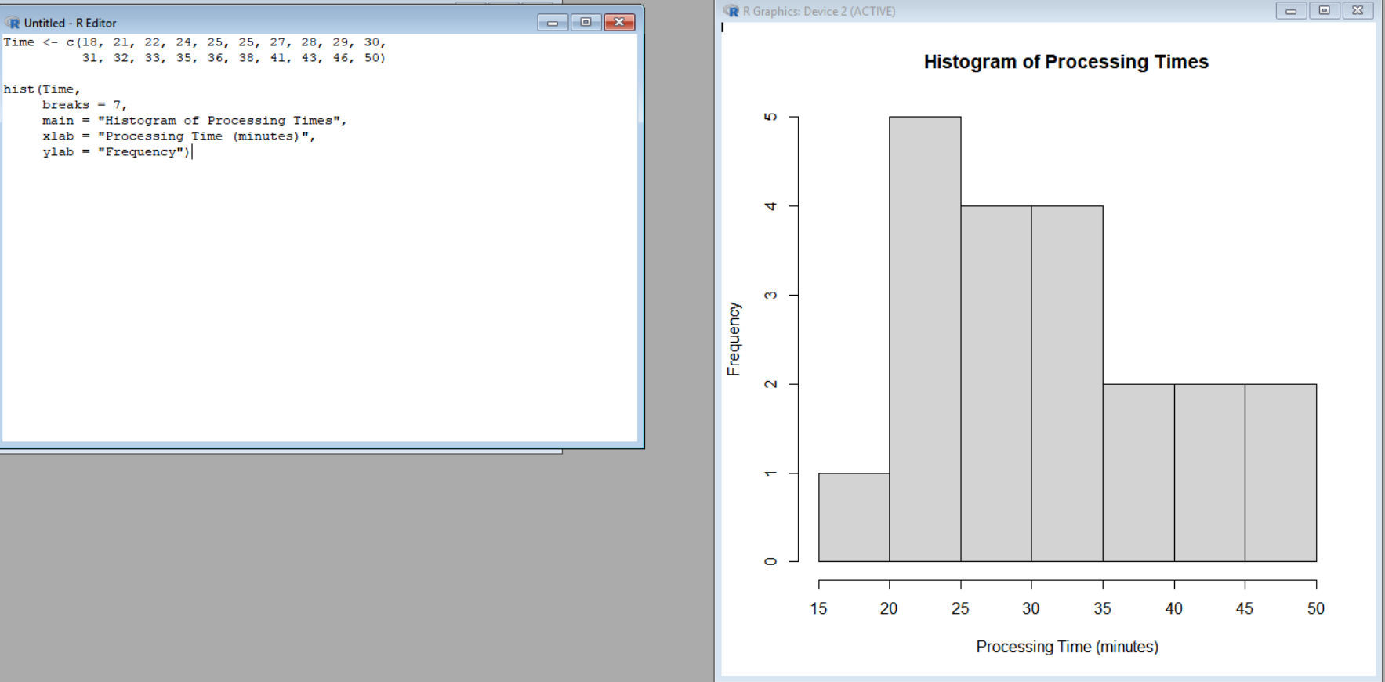

- Density Plot:
Time <- c(18, 21, 22, 24, 25, 25, 27, 28, 29, 30,
31, 32, 33, 35, 36, 38, 41, 43, 46, 50)

plot(density(Time),
main = "Density Plot of Processing Times",
xlab = "Processing Time (minutes)",
ylab = "Density")
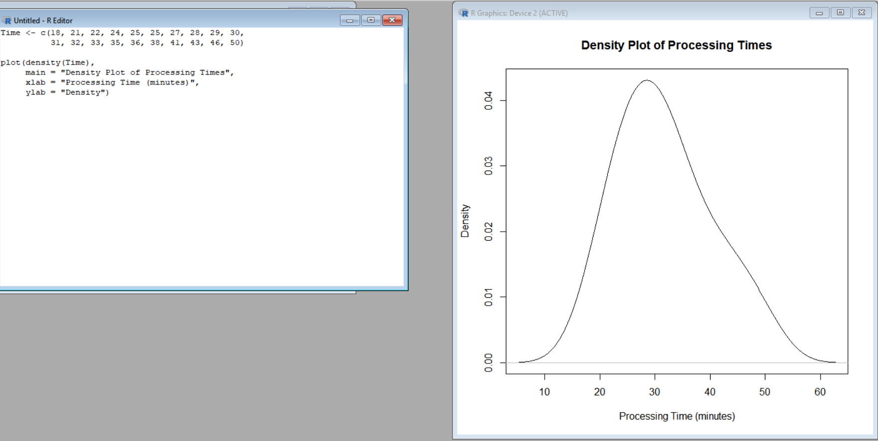

- ECDF:
Time <- c(18, 21, 22, 24, 25, 25, 27, 28, 29, 30,
31, 32, 33, 35, 36, 38, 41, 43, 46, 50)

plot(ecdf(Time),
main = "ECDF of Processing Times",
xlab = "Processing Time (minutes)",
ylab = "Cumulative Probability")
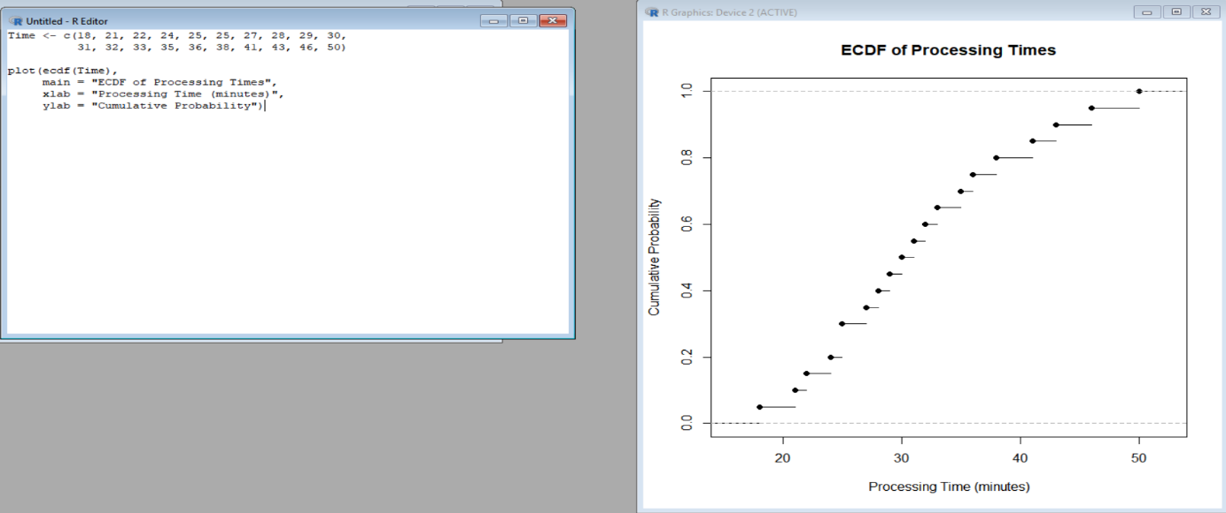

Interpretation:
- Histogram: Shows the frequency distribution of processing times. Most observations are concentrated around 25–38 minutes, while a few values extend toward 50 minutes.
- Density plot: Gives a smoother view of the distribution and makes the overall shape easier to observe. The distribution shows a slight right skew because of the larger values near 43–50.
- ECDF: Shows the cumulative proportion of observations below or equal to each processing time. It is especially useful for determining what percentage of tasks finish within a particular time.
- Center: The observations are centered roughly around the low-to-mid 30-minute range.
- Spread: The values range from 18 to 50 minutes, showing a reasonably wide spread.
- Skewness: The distribution has a slight positive/right skew due to the higher processing times.
- Cumulative behavior: The ECDF directly communicates how quickly the cumulative percentage increases as processing time increases.

Q2 Q-Q Plot and Normality Analysis:
- Normal Q-Q Plot
Response <- c(42, 45, 47, 49, 50, 51, 52, 53, 54, 55,
56, 57, 58, 60, 61, 63, 66, 70, 76, 85)

qqnorm(Response,
main = "Normal Q-Q Plot of Response Times",
xlab = "Theoretical Quantiles",
ylab = "Sample Quantiles")

qqline(Response,
col = "red",
lwd = 2)
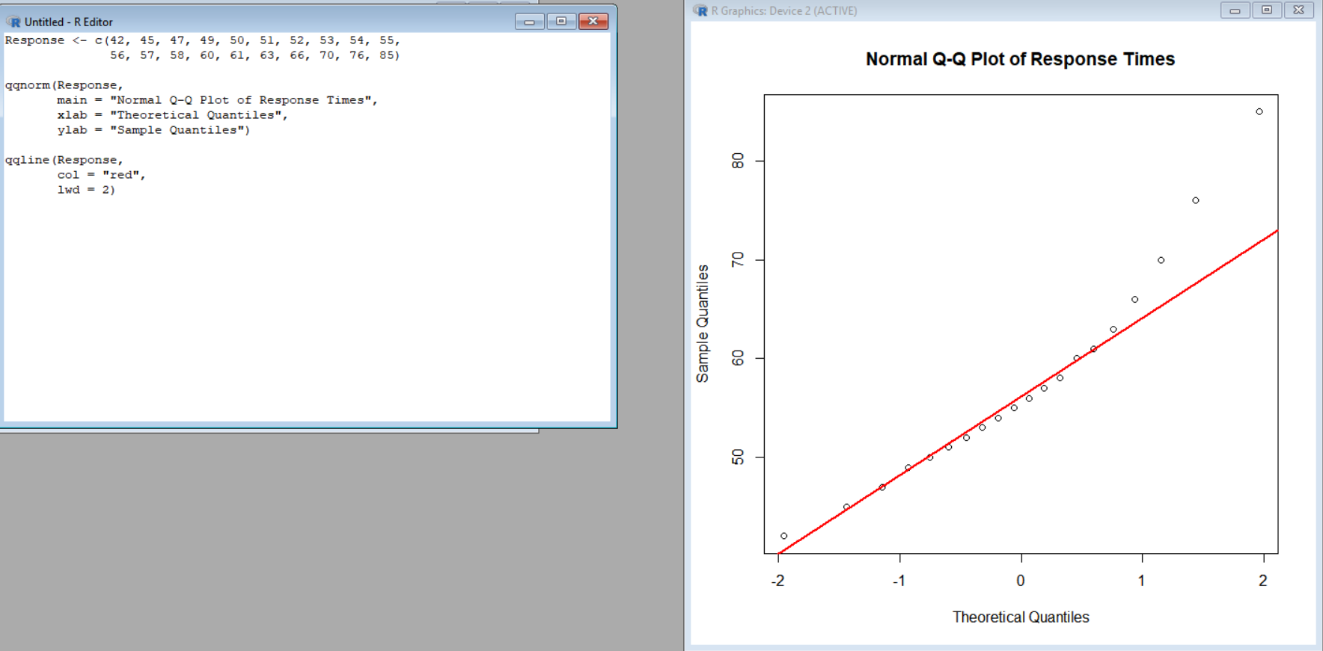

- Histogram:
Response <- c(42, 45, 47, 49, 50, 51, 52, 53, 54, 55,
56, 57, 58, 60, 61, 63, 66, 70, 76, 85)

hist(Response,
breaks = 7,
main = "Histogram of Response Times",
xlab = "Response Time (seconds)",
ylab = "Frequency")
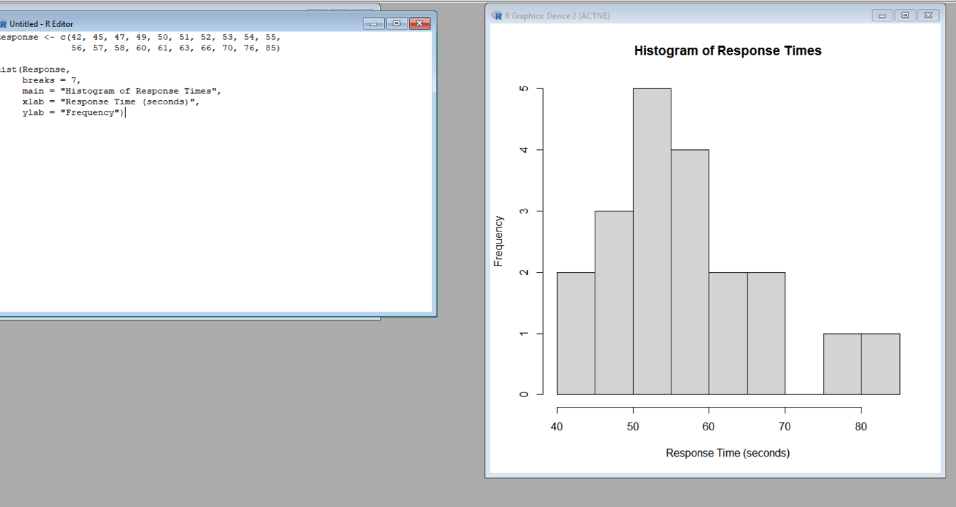

- Density plot:
Response <- c(42, 45, 47, 49, 50, 51, 52, 53, 54, 55,
56, 57, 58, 60, 61, 63, 66, 70, 76, 85)

plot(density(Response),
main = "Density Plot of Response Times",
xlab = "Response Time (seconds)",
ylab = "Density")

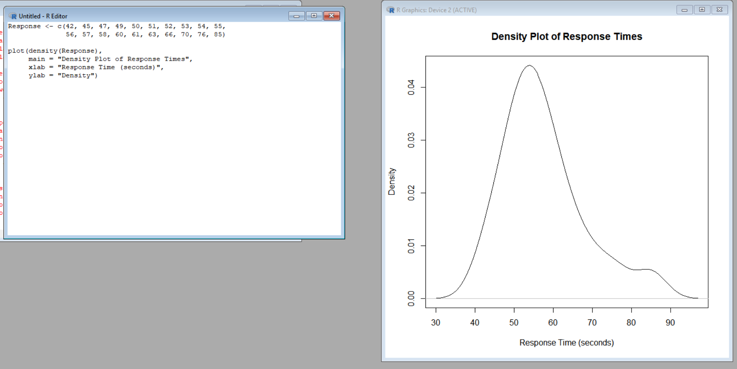

Interpretation:
- If the observations are normally distributed, the points in the Q-Q plot should approximately follow the reference line.
- Most of the middle observations are reasonably close to the reference pattern.
- The upper tail, particularly the observations around 76 and 85 seconds, deviates noticeably from the expected normal pattern.
- The histogram/density plot also shows a longer right tail.
- Therefore, the data are not perfectly normally distributed and show evidence of right-tail deviation.
- The value 85 seconds is particularly far from the main concentration of observations and may be considered a potential high-end unusual observation.

Q3 Visualizing Many Distributions:
Group_A <- c(52, 55, 57, 58, 60, 61, 62, 64, 65, 66,
68, 70, 72, 74, 78)

Group_B <- c(45, 49, 51, 53, 55, 56, 58, 59, 60, 62,
63, 65, 67, 69, 71)

Group_C <- c(58, 60, 61, 63, 64, 65, 67, 68, 70, 71,
72, 74, 76, 80, 84)
Scores <- c(Group_A, Group_B, Group_C)

Group <- factor(c(rep("Group A", length(Group_A)),
rep("Group B", length(Group_B)),
rep("Group C", length(Group_C))))

data <- data.frame(Group, Scores)
boxplot(Scores ~ Group,
data = data,
main = "Examination Score Distribution by Group",
xlab = "Student Group",
ylab = "Examination Score",
col = c("lightblue", "lightgreen", "lightpink"))
stripchart(Scores ~ Group,
data = data,
vertical = TRUE,
method = "jitter",
pch = 19,
add = TRUE)

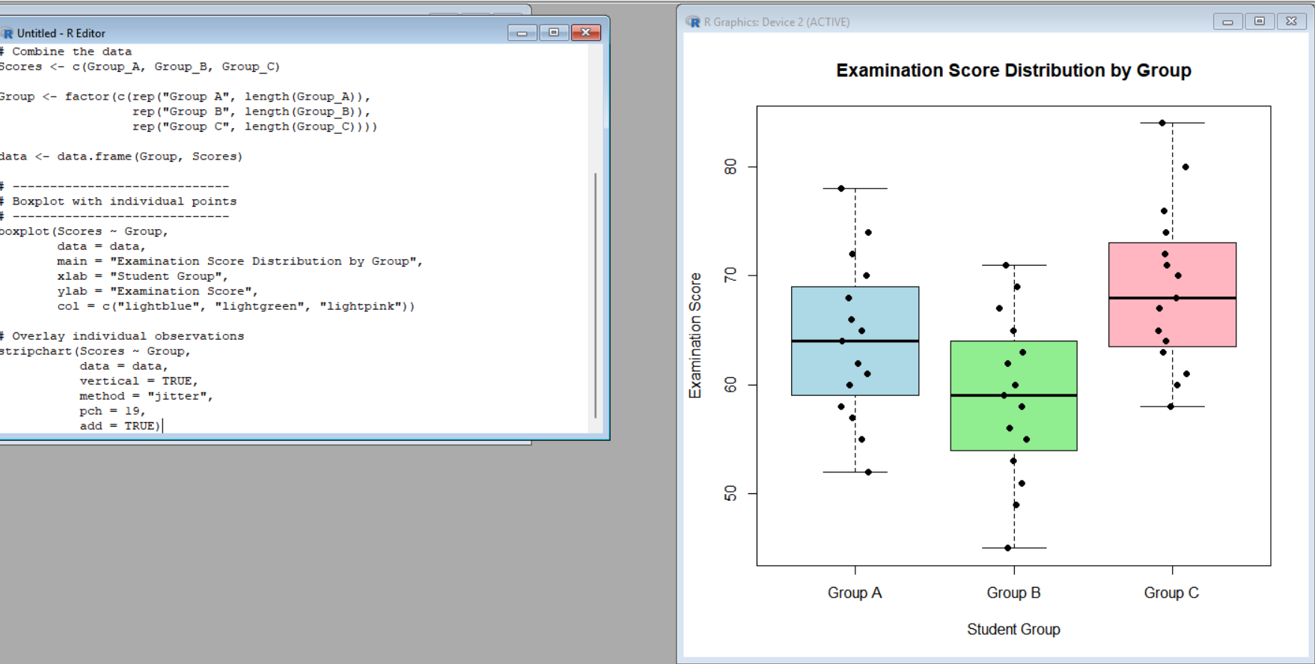

Interpretation:
- Group A: Has a middle position around the mid-60s and a relatively broad range of scores.
- Group B: Has the lowest center, with scores extending from 45 to 71.
- Group C: Has the highest center and also reaches the highest score of 84.
- Group C therefore generally performs better than Groups A and B.
- The boxplots allow the centers, spreads, and potential unusual observations to be compared on the same scale.
- Overlaying individual observations helps show the actual data values rather than relying only on summary statistics.
- A combined visualization is more informative than three separate plots because the groups can be compared directly and consistently.

Q4 Relationships and Multivariate Visualization:

Advertising <- c(10, 12, 14, 16, 18, 20, 22, 24, 26,
28, 30, 32, 34, 36, 38)

Visits <- c(120, 135, 150, 165, 180, 195, 210, 225,
245, 260, 275, 290, 305, 320, 340)

Sales <- c(48, 50, 53, 55, 58, 61, 63, 66, 69,
71, 74, 77, 80, 83, 86)
plot(Advertising, Sales,
main = "Advertising Expenditure vs Sales",
xlab = "Advertising Expenditure",
ylab = "Sales",
pch = 19,
cex = Visits / 100)
model <- lm(Sales ~ Advertising)

abline(model,
lwd = 2)

grid()
correlation <- cor(Advertising, Sales)

print(paste("Correlation =", round(correlation, 3)))
summary(model)

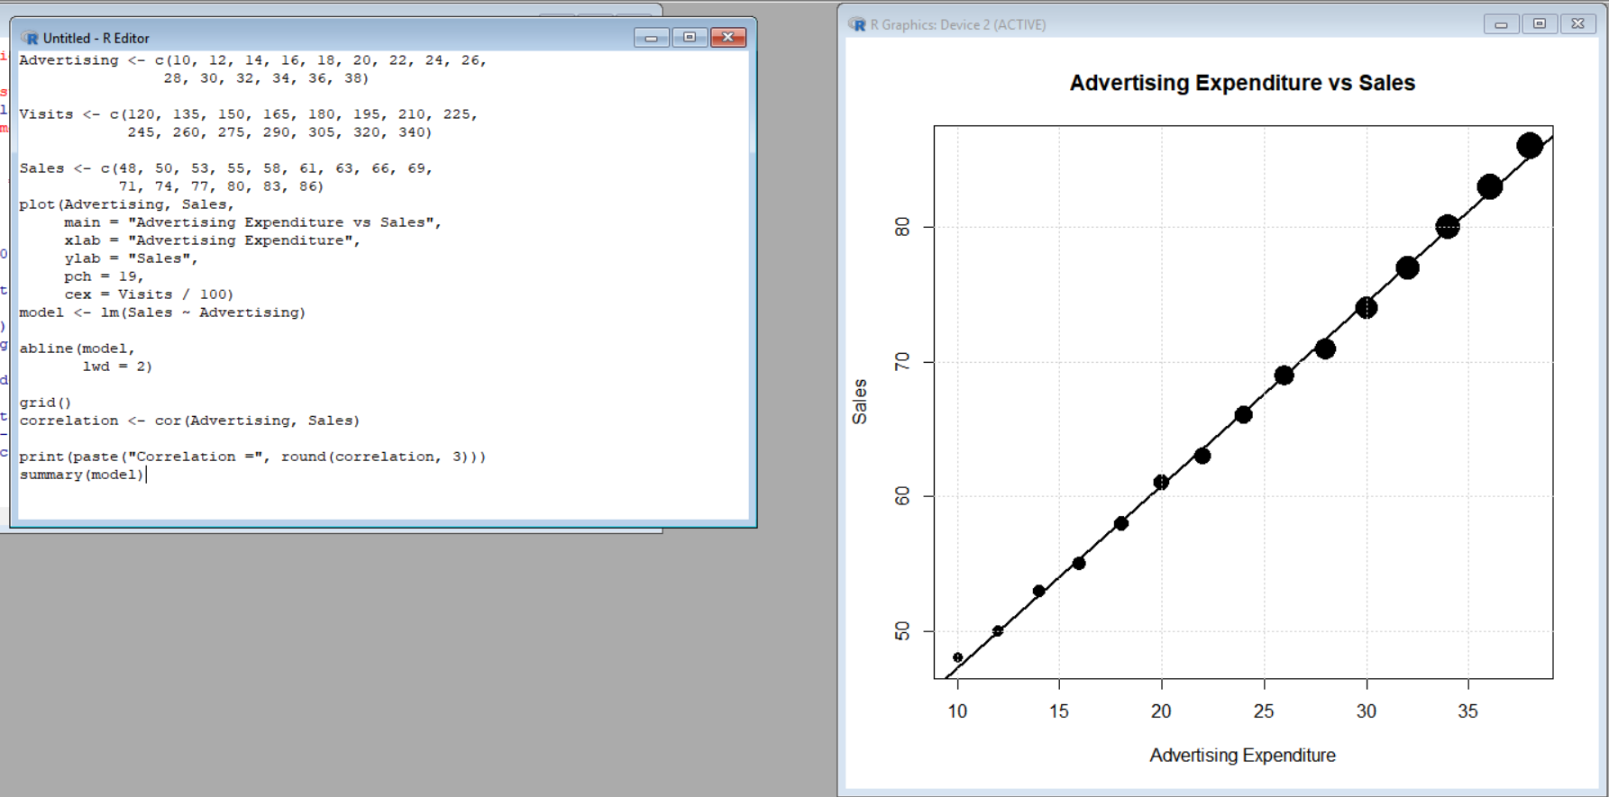

Interpretation:
- There is a strong positive relationship between advertising expenditure and sales.
- As advertising expenditure increases, sales also increase.
- The points follow a fairly consistent upward trend, indicating that the relationship is strong.
- Website visits are incorporated using point size. Larger points represent higher numbers of website visits.
- This additional variable provides useful information because website visits also increase along with advertising expenditure and sales.
- However, using too many visual encodings can make a graph difficult to understand. Here, point size is relatively simple and adds information without requiring another separate graph.
- The fitted regression line summarizes the overall positive relationship between advertising expenditure and sales.

Q5 Misleading Visualization and Redesign:

Department <- c("CSE", "ECE", "EEE", "MECH",
"CIVIL", "AIDS", "IT")

Pass_Percentage <- c(91, 93, 92, 89, 90, 95, 94)

data <- data.frame(Department, Pass_Percentage)

1. MISLEADING VISUALIZATION

barplot(Pass_Percentage,
names.arg = Department,
ylim = c(85, 96),
main = "Pass Percentage by Department (Truncated Axis)",
xlab = "Department",
ylab = "Pass Percentage (%)",
col = "orange",
border = "black")

2. REDESIGNED VISUALIZATION
data_sorted <- data[order(data$Pass_Percentage), ]

barplot(data_sorted$Pass_Percentage,
names.arg = data_sorted$Department,
ylim = c(0, 100),
main = "Pass Percentage by Department",
xlab = "Department",
ylab = "Pass Percentage (%)",
col = "skyblue",
border = "black")
text(x = seq_along(data_sorted$Pass_Percentage),
y = data_sorted$Pass_Percentage + 3,
labels = paste0(data_sorted$Pass_Percentage, "%"),
cex = 0.9)

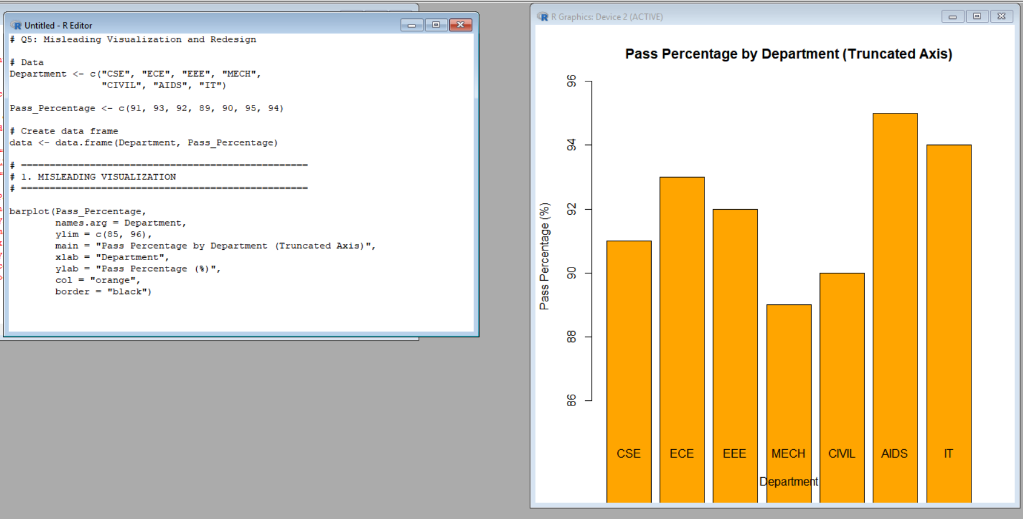

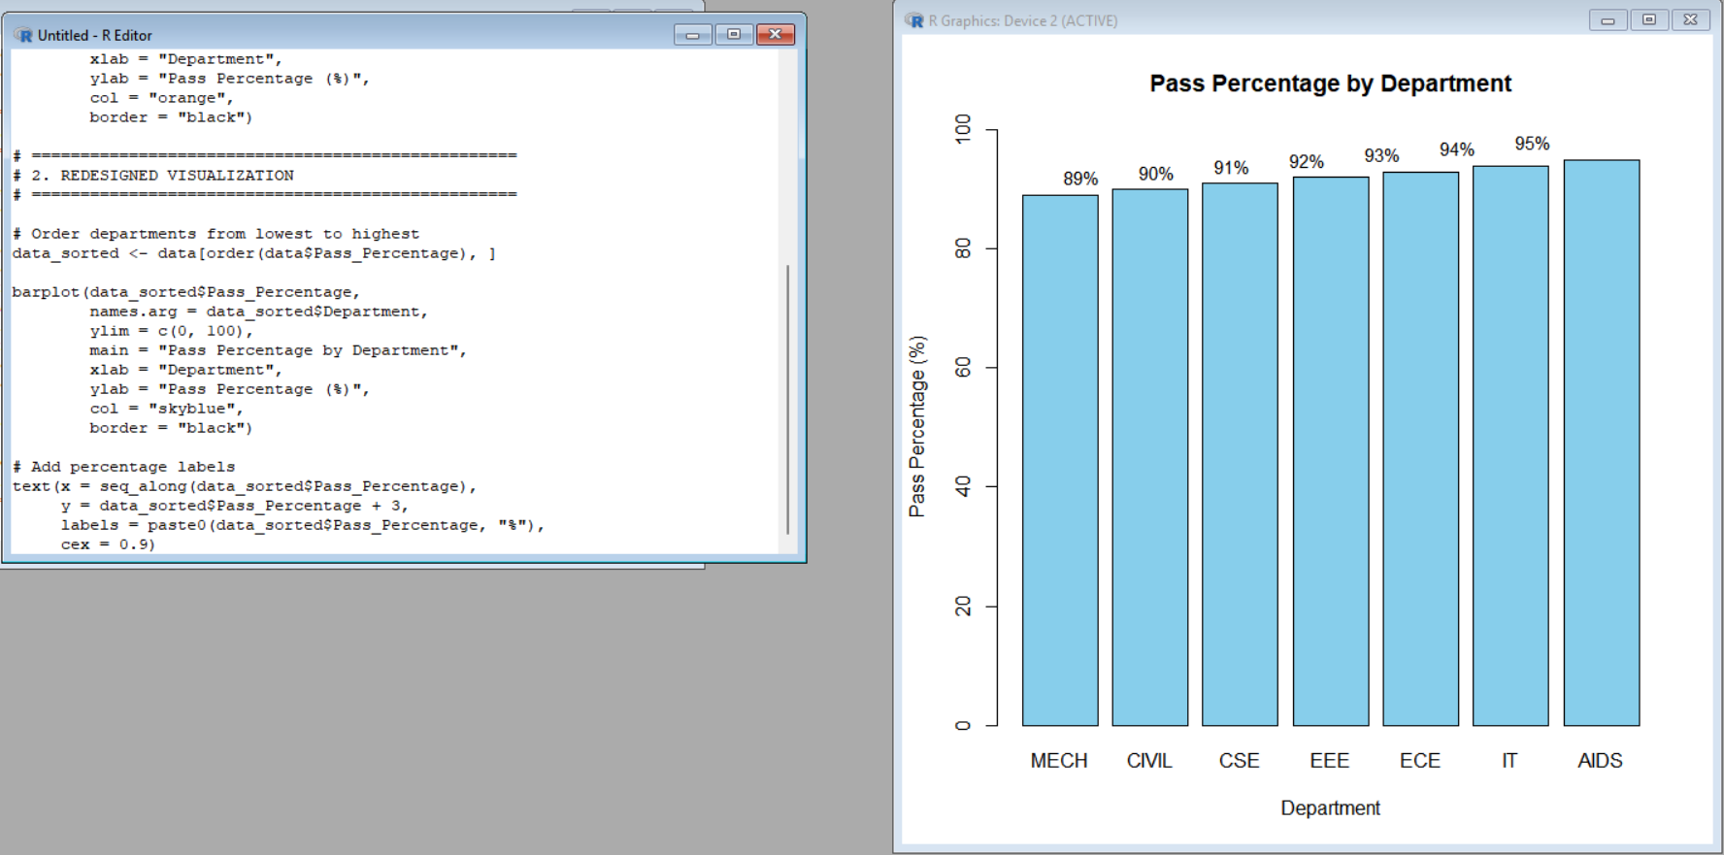

Interpretation:
- The first visualization uses a truncated y-axis beginning at 85% rather than zero.
- Because the bars start at 85%, relatively small differences in pass percentages can appear much larger than they actually are.
- For example, the difference between 89% and 95% is only 6 percentage points, but a truncated axis can visually exaggerate this difference.
- The redesigned visualization starts the y-axis at 0%, giving the bars an appropriate baseline.
- The departments are ordered from the lowest to the highest pass percentage, making comparison easier.
- Percentage labels provide the exact values and improve readability.
- Therefore, the redesigned visualization communicates the data more honestly, clearly, and accurately.
- For accessibility, clear labels and a simple baseline make the chart easier to interpret without relying only on visual differences.

